For our lab on the photoelectric effect, we will be using the following simulation:
https://www.thephysicsaviary.com/Physics/Programs/Labs/PhotoelectricEffect/
Once you launch the simulation, you will see a screen like this:
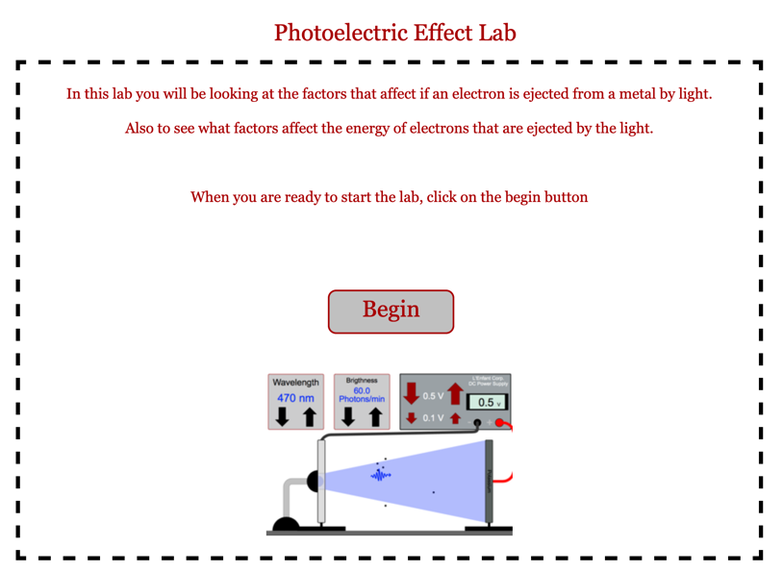
Notice that there are controls for the wavelength of light (rather than the frequency); the brightness – or intensity – as measured by the number of photons/min; and for the applied voltage. The voltage can be changed by either 0.1 V or 0.5 V at a time.
Once you open the simulation, you should see the following default settings:
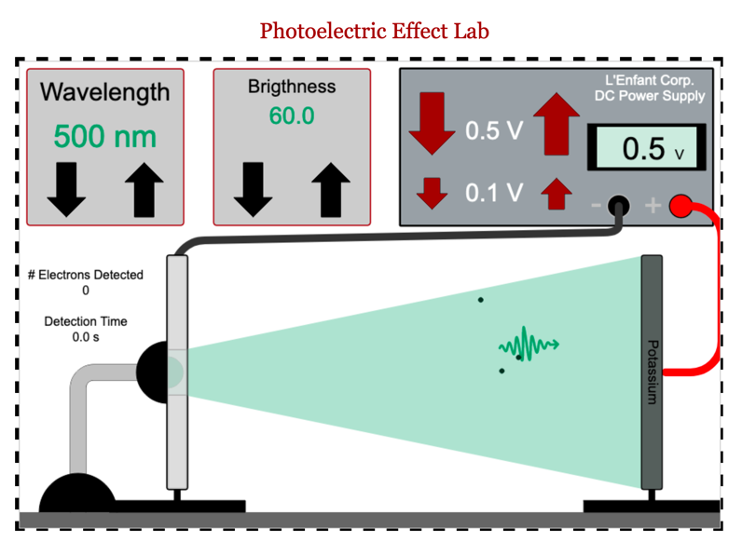
Notice that below the wavelength controls, there are readouts for the number of electrons detected, and the detection time. There is, however, no pause button, and the timer will only begin if electrons are emitted, and detected by the detector on the left. If no electrons are detected, we will record the current as zero. Be patient! It takes a few seconds in the simulation for electrons to be emitted, and then to cross the gap to be detected. We can use this information to calculate current:
$$I=\frac{Ne}{∆t}$$
Where N is the number of electrons, e is the charge of one electron.

Varying Wavelength
For this part of the experiment, we will be examining the effects of changing wavelength on the number of electrons emitted from the surface of potassium.
To set this up,
- Use the controls to set the voltage to zero.
- Turn up the brightness to its maximum setting.
- Set the wavelength to 600 nm. This is on the red side of the visible spectrum.
- For each measurement, be sure to collect data for 30 seconds or more.
- Now complete the following measurements using the simulator. Here, your goal is to find the cutoff wavelength (and therefore, the cutoff frequency) – in other words, the wavelength at which the current changes from zero to non-zero. You should be sure to collect enough data to be sure that you know at what wavelength this will occur.
Wavelength (nm) | # electrons detected | Detection time | Frequency (Hz) | Current (A)
600
550
540
530
520
510
500
490
480
470
460
450
440
430
420
410
400

- Next, create a graph of current vs. frequency. Be sure to label the axes. Insert that graph here. Identify, using the data table and the graph, what the cutoff frequency is.

- Beyond the cutoff, does the current appear to be increasing, decreasing, or staying the same? Test your hypothesis by collecting some more current data in that same range of wavelengths to see if it holds true.

Now let’s repeat the experiment, but with a different metal. Brightness should remain at maximum, and voltage at zero. Switch metals by clicking on the electrode connected to the red wire, with the label reading potassium, until it now reads sodium.
- Again, complete the following measurements using the simulator. Here, your goal is to find the cutoff wavelength (and therefore, the cutoff frequency) – in other words, the wavelength at which the current changes from zero to non-zero. You should be sure to collect enough data to be sure that you know at what wavelength this will occur.
Wavelength (nm) | # electrons detected | Detection time | Frequency (Hz) | Current (A)
600
550
540
530
520
510
500
490
480
470
460
450
440
430
420
410
400

- Next, create a graph of current vs. frequency. Be sure to label the axes. Insert that graph here. Identify, using the data table and the graph, what the cutoff frequency is.

- How are the two graphs (from question 2, and question 5) similar to each other?

- How are the two graphs different?

Varying Brightness
For this part of the experiment, we will be examining the effects of changing brightness on the number of electrons emitted from the surface of potassium.
To set this up, first reset the simulation to the original settings.
- Use the controls to set the voltage to zero.
- Turn up the brightness to its maximum setting.
- Set the wavelength to 470 nm.
- Make sure that you have reset the metal back to potassium.
- For each measurement, be sure to collect data for 30 seconds or more.
- Now, as we decrease the brightness of the light, record the # electrons and detection time, and calculate the current. Then you will increase the brightness of the light from 0 to the maximum, following the same process.
Brightness (photons/min) | # electrons detected | Detection time | Current (A)
120
110
100
90
80
70
60
50
40
30
20
10
0
10
20
30
40
50
60
70
80
90
100
110
120

- Next, create a graph of current (dependent) vs. brightness (independent). Be sure to label the axes. Add a trendline, and the equation for the trendline. Insert that graph here.

- What trends do you observe as the brightness decreases?

Varying the metal
For this part of the experiment, we will be examining the effects of changing the metal on the number of electrons emitted.
To set this up, first reset the simulation to the original settings.
- Use the controls to set the voltage to zero.
- Turn up the brightness to its maximum setting.
- Make sure that you have reset the metal back to potassium.

- For each metal, we are going to determine the maximum wavelength that produces a current for each metal, and use that information to calculate that metal’s work function.
Metal | Wavelength (nm) | Frequency (Hz) | Calculated Work Function (eV)
Potassium
Platinum
Sodium
Silver
Cesium
Gold
Copper

- Look up the value for the work function for each metal. Find the percent error for each.
Metal | Calculated Work Function (eV) | Theoretical Work function | % error
Potassium
Platinum
Sodium
Silver
Cesium
Gold
Copper

Varying the applied voltage
For this part of the experiment, we will be examining the effects of changing the applied voltage on the number of electrons emitted, and determining if that changes based on the wavelength of the light.
To set this up, first reset the simulation to the original settings.
- Use the controls to set the voltage to zero.
- Turn up the brightness to its maximum setting.
- Make sure that you have reset the metal back to potassium.

- For potassium, we are going to determine the applied voltage at which NO electrons are detected, as a function of the wavelength of light that is shining on the metal. To do this, you will
  - first set the wavelength of light shining on the potassium surface
  - next, slowly increase the voltage applied. You will have found the “stopping voltage” when the photoelectrons emitted from the potassium surface do not quite reach the detector, so that no current at all is detected.
  - Then you will calculate the frequency of the photons, and from there, use the frequency to calculate the photon energy in eV.
Wavelength (nm) | Stopping voltage (Volts) | Frequency (Hz) | Photon energy (eV)
200 nm
250 nm
300 nm
350 nm
400 nm

- Create a graph of the stopping voltage (on the x-axis) vs. the photon energy (on the y-axis). Create a trendline, and insert the equation of the line. Be sure to label axes on your graph. Insert a screenshot of that graph here.

- Using the equation for your trendline, determine the work function for potassium. Show how you get this value from the equation for your trendline.

- Compare the work function you determined using the graph here with the work function for potassium you found in question 11, and to the theoretical value you found in question 12.

